Network Topology Assignment
1. Star, Bus, and Mesh Topology Diagrams
A. Star Topology
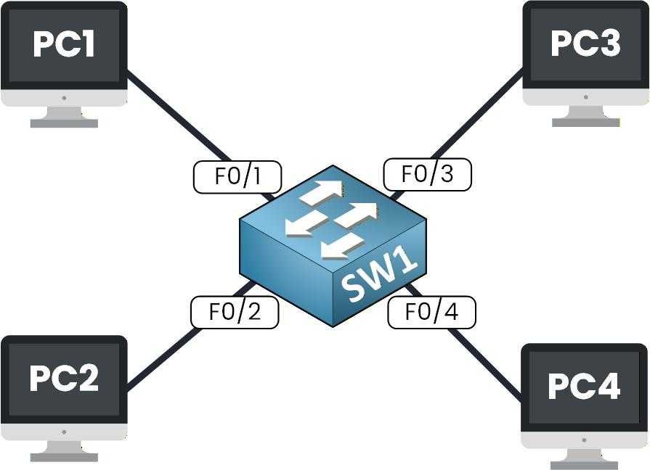
Example: Instagram
All devices connect to a central switch or access point. This structure makes it easy to manage devices and troubleshoot connection problems.
B. Bus Topology
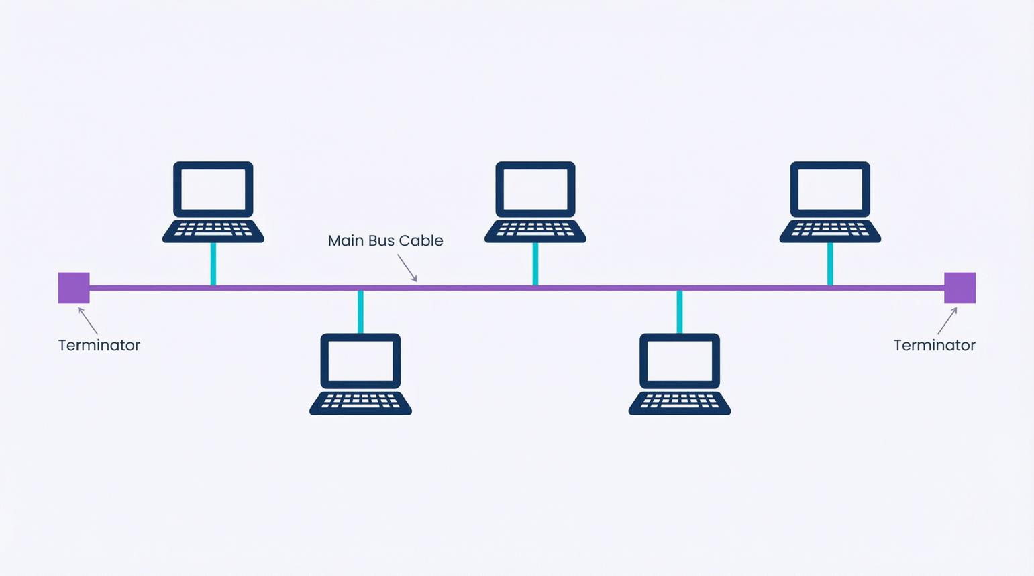
Example: File sharing in an older office LAN
All computers share one main backbone cable. It uses less cable, but a fault in the backbone can disrupt the whole network.
C. Mesh Topology
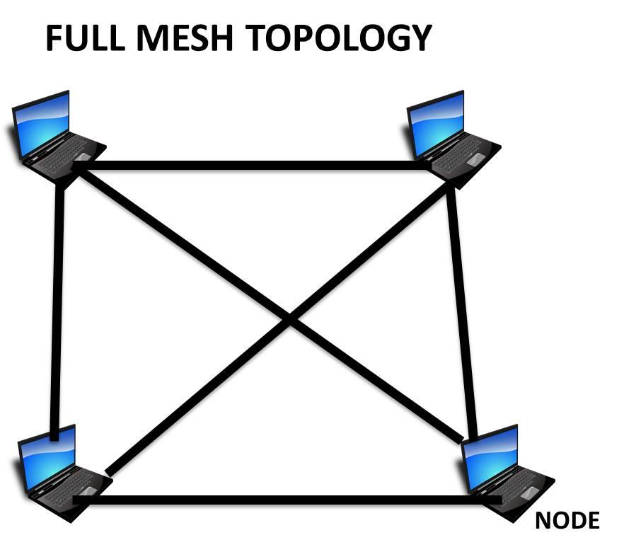
knowcomputing.com
Example: Reliable data-center connections supporting Flipkart
Devices or network nodes have multiple paths between them. If one link fails, traffic may travel through another available path.
Note: These apps do not necessarily use only the topology shown. The examples illustrate where each topology's design could be useful.

2. Comparison Table: Star, Bus, Ring, and Mesh
Topology | 4 Advantages (Pros) | 4 Disadvantages (Cons) | Best Use Case
Star | 1. Easy to install. 2. Easy troubleshooting. 3. Easy to add devices. 4. One cable failure affects only one device. | 1. Needs more cables. 2. Requires a central switch. 3. Switch failure affects all devices. 4. Higher cost than a simple bus network. | Office LAN; computers processing Zomato orders.
Bus | 1. Uses less cable. 2. Low installation cost. 3. Simple for small setups. 4. No central switch required. | 1. Backbone failure stops communication. 2. Performance decreases with heavy traffic. 3. Troubleshooting is difficult. 4. Limited scalability. | Small, older wired LANs.
Ring | 1. Organized data flow. 2. Predictable access to the network. 3. Can reduce data collisions. 4. Suitable for some specialized networks. | 1. A link failure may disrupt the ring. 2. Adding devices can be difficult. 3. Troubleshooting can be complex. 4. Changes may interrupt communication. | Specialized industrial networks and some ring-based fiber networks.
Mesh | 1. Highly reliable. 2. Multiple paths for data. 3. Can recover from link failures. 4. Good redundancy. | 1. Expensive installation. 2. Requires many connections. 3. Complex configuration. 4. Difficult to maintain as the network grows. | Data centers and resilient networks supporting services such as Paytm.

3. Best Topology for a Multiplayer Mobile Game
Chosen topology: Client-Server (Star-like architecture)
- All players' mobile devices connect to a central game server to exchange game information.
- The server processes player movements and game events, helping keep the game synchronized.
- A well-connected server can provide fast responses, while backup servers and network links improve reliability.
- This design has a manageable cost compared with a fully connected mesh, although server hosting and maintenance still cost money.
4. Flipkart-Style Warehouse — 8 Computers
Recommended topology: Star topology
Main Network Switch
PC 1
PC 2
PC 3
PC 4
PC 5
PC 6
PC 7
PC 8
Each computer connects separately to the central switch.
Reasoning (2–3 lines):
Star topology is ideal because it is easy to install, troubleshoot, and maintain. If one computer's cable fails, the other computers can continue working. More computers can be added by connecting them to the switch, provided it has available ports.

